1.
#include<stdio.h>
int main() {
int arr[5] = {1, 2, 3, 4, 5};
int *ptr = arr;
int sum = 0;
for (int i = 0; i < 5; i++) {
sum += *(ptr + i); // Add elements using pointer arithmetic
}
printf("Sum of array elements: %d\n", sum);
return 0;
}
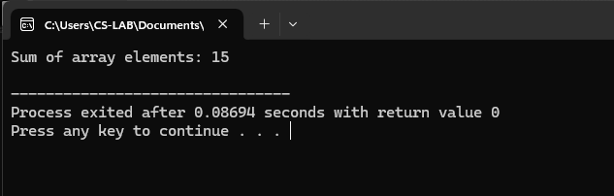
2.
#include <stdio.h>
int main() {
int arr[100], n;
int *ptr, largest;
printf("Enter number of elements: ");
scanf("%d", &n);
printf("Enter %d elements:\n", n);
for (int i = 0; i < n; i++) {
scanf("%d", &arr[i]);
}
ptr = arr; // pointer to first element
largest = *ptr; // assume first element is largest
for (int i = 1; i < n; i++) {
if (*(ptr + i) > largest) {
largest = *(ptr + i);
}
}
printf("The largest element in the array is: %d\n", largest);
return 0;
}
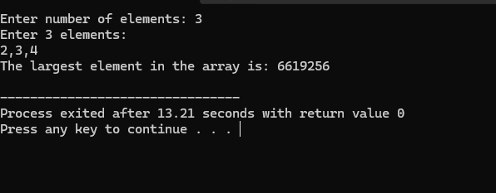
3.
#include <stdio.h>
int main() {
int arr[100], n, i;
int *p; // single pointer
int **dp; // double pointer
int max;
printf("Enter number of elements: ");
scanf("%d", &n);
printf("Enter array elements:\n");
for (i = 0; i < n; i++)
scanf("%d", &arr[i]);
p = arr; // pointer points to first element
dp = &p; // double pointer points to pointer
max = **dp; // initialize max with first element
for (i = 1; i < n; i++) {
*p = arr[i]; // move pointer to next element manually
if (**dp < arr[i])
max = arr[i];
}
printf("Largest element = %d\n", max);
return 0;
}
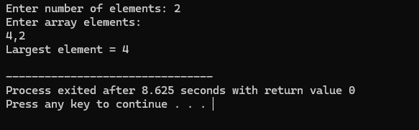
4.
#include <stdio.h>
int main() {
int a, b, temp;
int *p1, *p2;
printf("Enter two numbers: ");
scanf("%d %d", &a, &b);
p1 = &a;
p2 = &b;
// Swapping using pointers
temp = *p1;
*p1 = *p2;
*p2 = temp;
printf("After swapping:\n");
printf("a = %d\n", a);
printf("b = %d\n", b);
return 0;
}
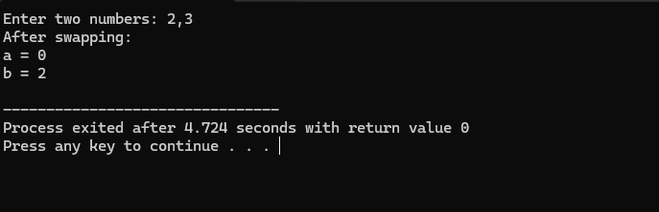

5.
#include <stdio.h>
#include <stdlib.h>
int main() {
int N;
float *marks;
float sum = 0.0, average;
printf("Enter the number of students: ");
scanf("%d", &N);
if (marks == NULL) {
printf("Memory allocation failed!\n");
return 1;
}
for (int i = 0; i < N; i++) {
printf("Enter marks for student”);
scanf("%f", (marks + i));
sum += *(marks + i);
}
printf("\nMarks of all students:\n");
for (int i = 0; i < N; i++) {
printf("Student %.2f\n", marks + i);
}
average = sum / N;
printf("\nAverage marks = %.2f\n", average);
free(marks);
return 0;
}

6.
#include <stdio.h>
#include <stdlib.h>
int main() {
int i;
float *salaries;
// Step 1: Allocate memory for 4 employees
salaries = (float *)malloc(4 * sizeof(float));
if (salaries == NULL) {
printf("Memory allocation failed!\n");
return 1;
}
// Input salaries for 4 employees
printf("Enter salaries of 4 employees:\n");
for (i = 0; i < 4; i++) {
printf("Employee %d: ", i + 1);
scanf("%f", (salaries + i)); // same as &salaries[i]
}
// Display salaries of 4 employees
printf("\nSalaries of 4 employees:\n");
for (i = 0; i < 4; i++) {
printf("Employee %d: %.2f\n", i + 1,*(salaries + i));}
// Step 2: Expand memory for 3 more employees
salaries = (float *)realloc(salaries, 7 * sizeof(float));
if (salaries == NULL) {
printf("Memory reallocation failed!\n");
return 1;
}
// Input salaries for 3 new employees
printf("\nEnter salaries of 3 new employees:\n");
for (i = 4; i < 7; i++) {
printf("Employee %d: ", i + 1);
scanf("%f", (salaries + i));
}
// Display salaries of all 7 employees
printf("\nSalaries of all 7 employees:\n");
for (i = 0; i < 7; i++) {
printf("Employee %d: %.2f\n", i + 1,*(salaries + i));
}
// Free the allocated memory
free(salaries);
return 0;
}
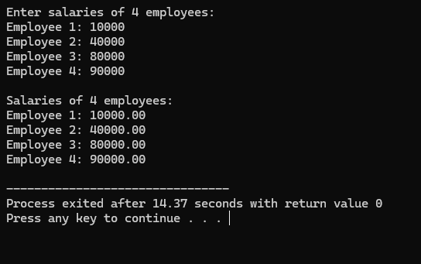
7.
#include <stdio.h>
#include <stdlib.h>
int main() {
int N, i;
int *scores;
int highest, lowest;
float sum = 0.0, average;
// Input number of players
printf("Enter number of players: ");
scanf("%d", &N);
// Allocate memory dynamically
scores = (int *)malloc(N * sizeof(int));
if (scores == NULL) {
printf("Memory allocation failed!\n");
return 1;
}
// Input scores using pointer notation
for (i = 0; i < N; i++) {printf("Enter score for player %d: ", i + 1);
scanf("%d", (scores + i)); // same as &scores[i]
sum += *(scores + i);
}
// Initialize highest and lowest
highest = lowest = *(scores + 0);
// Find highest and lowest using pointer arithmetic
for (i = 1; i < N; i++) {
if (*(scores + i) > highest)
highest = *(scores + i);
if (*(scores + i) < lowest)
lowest = *(scores + i);
}
// Calculate average
average = sum / N;
// Display scores and statistics
printf("\nScores of players:\n");
for (i = 0; i < N; i++) {
printf("Player %d: %d\n", i + 1,*(scores + i));
}
printf("\nHighest score: %d\n", highest);
printf("Lowest score: %d\n", lowest);
printf("Average score: %.2f\n", average);
// Free allocated memory
free(scores);
return 0;
}
